Homestay Application Form

Last Name
First Name
E-mail
Phone/WhatsApp | + (country)-(area)-(number)
Date of Birth | DD.MM.YYY
Gender
Native Language
Citizenship
Country and City of Residence
Home Address
Emergency Contact Name
Relationship to You
Phone Number of the Emergency Contact
Which city in Canada are you going to?
Which school in Canada are you attending?
Arrival Date | DD.MM.YYY
Departure Date | DD.MM.YYY
Do you need Homestay? | Yes or No
Do you need Airport Pick Up? | Yes or No
Do you need Airport Drop Off? | Yes or No
Do you need Basic Custodianship? | Yes or No
Do you need Comprehensive Custodianship? | Yes or No
Do you need a Custodianship Letter Only? | Yes or No
Type of Room | Single or Shared
Meals a Day | 3 Meals, 2 Meals, No Meals
Allergies, Health Limitations, Preferences (extra charges may apply), Any Additional Information and Details

Services and Fees
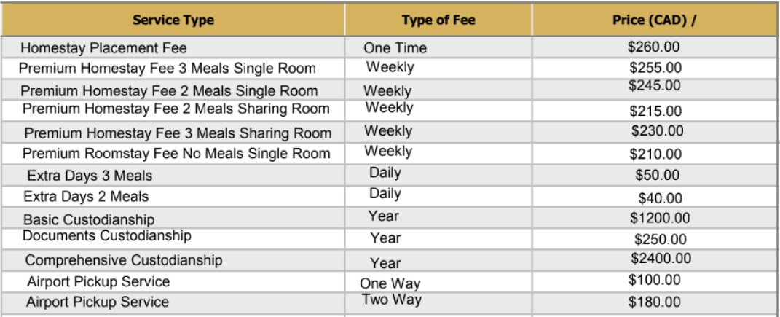
Please send the form to getintomarket@gmail.com along with your passport copy and a school LOA.

